Factors of Production
Item | Start-up cost | Target population | Factors of Production | Supply Factors
Jewelry  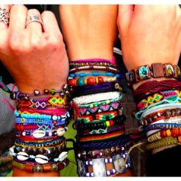 | $2.00 | *SVHS Students  *Staff  *Parents  *Family  *Friends | Land: metal  Labor: employee putting the components together  Capital  Human: hand made  Physical: Jewelry sharpener machine  Need: bracelet, cuff earrings  Have: money | *Expectations  *Start-up Cost  *Regulation  *Subsides  *Technology and Productivity  *Number of Supplies

Item | Start-up cost | Target population | Factors of Production | Supply Factors
Dividers | $2.00 | *SVHS Students  *Staff  *Parents  *Family  *Friends | Land: corn  Labor: machine  Capital  Human: employee packaging  Physical: sewing machine  Need: dividers  Have: money | *Expectations  *Start-up Cost  *Regulations  *Subsides  *Technology and Productivity  *Number of Supplies
Item | Start-up cost | Target population | Factors of Production | Supply Factors
Bows  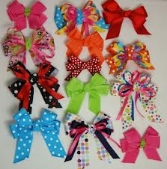 | $2.00 | *SVHS Students  *Staff  *Parents  *Family  *Friends | Land: cotton  Labor: Picking cotton  Capital  Human: Physical Sewing machine  Physical: Nothing  Need: bows  Have: money | *Expectations  *Start-up Cost  *Regulations  *Subsides  *Technology and Productivity  *Number of Supplies

